**NOTIFYING SCREENING PROGRAMMES OF PATIENTS WITH LEARNING DISABILITIES (BARNSLEY)**

**BACKGROUND**

A process has been developed to enable practices to notify the teams who manage screening programmes of patients who have learning disabilities. Practices can run bespoke reports and save the results into a csv file which can be emailed to designated contacts within the screening teams. This process will allow the screening teams to be better informed about which patients have a learning disability and be in a better position to make reasonable adjustments as required.

Instructions are provided below for EMIS Web and SystmOne practices.

**SYSTMONE INSTRUCTIONS**

1. Locate the report under **SYICB Shared Resources > Learning Disabilities > Screening Programmes**
2. Select the required report and click **Run**  
   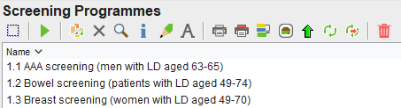
3. Once the report has run, click **Show Patients**  
   
4. Click the **Select Output** button  
   
5. Select **Pre-defined report output** then find and select **Screening Programmes (LD)**  
   *Tip: Click on the first report output in the list, click* ***Ctrl+F*** *to bring up the Search box, type ‘****screening prog****’ and click* ***Find Next*** *until the required output is located, then click* ***Close***

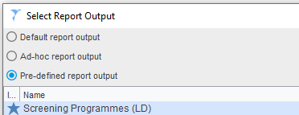

1. Click **Ok***The Report Output will be collated – this may take a few minutes depending on the number of patients included.*
2. Once the data has collated, click **Save All Pages to CSV**   
     
   *The CSV file will be generated and will open in Excel – this may take a few minutes depending on the number of patients included.*
3. In Excel, click **File > Save As**
4. Select a suitable folder to save the data file
5. Change the filename to include the screening programme and the practice code. Click **Save**
6. If asked about whether you want to keep the Workbook in the current format – click **Yes**
7. Close the file. If you are asked whether you want to save the changes, click **Don’t Save** (the required data has already been saved)
8. Repeat steps 2-12 for any remaining searches

**EMIS WEB INSTRUCTIONS**

1. In Population Reporting, locate the latest **LEARNING DISABILITIES** folder within the practice folder (this must be v1.6 or later). If the LEARNING DISABILITIES folder is not present, it will need to be copied from the Enterprise folder (BBS IT Services – Enterprise Search and Reports > Barnsley CCG Report Library > Clinical Apps & Data Quality)
2. Within the **LEARNING DISABILITIES** folder, right-click on the **Screening Programmes** folder and click **Run** to run all reports in the folder

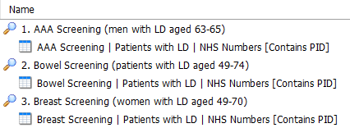

1. When the reports have completed, select each report in turn and click the **View Results** button
2. Click the **Export** button. Select the options as shown below and click **OK**

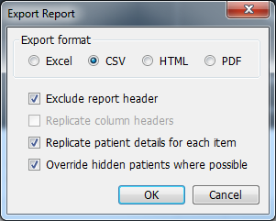

1. Select a suitable folder to save the data file
2. Change the filename to include the screening programme and the practice code. Ensure the **.csv** file extension is retained. Click **Save**
3. Click the **Close** button to close the EMIS Web Report Viewer
4. Repeat steps 3-7 for any remaining searches

**SUBMITTING THE DATA FILES**

Each data file should be emailed to the corresponding screening team’s mailbox:

* AAA: [dbh-tr.dbhaaa@nhs.net](mailto:dbh-tr.dbhaaa@nhs.net)
* Bowel: [gan-tr.north-east-bowel-hub@nhs.net](mailto:gan-tr.north-east-bowel-hub@nhs.net)
* Breast: [breastscreening.appointments@nhs.net](mailto:breastscreening.appointments@nhs.net)

Please include ‘Screening Programmes for patients with LD’ in the subject line of the email and include the practice name and practice code in the body of the email.

**HELP AND SUPPORT**

Queries about the programme of sharing information with the screening services should be directed to the Screening and Immunisation Team: [england.sybsit@nhs.net](mailto:england.sybsit@nhs.net)

Queries about the use of the LD Screening data should be directed to the individual screening team mailboxes.

Queries about accessing and running the reports should be logged using the BBS IT Self-Service Portal: [https://servicedesk.sheffield.nhs.uk](https://servicedesk.sheffield.nhs.uk/)